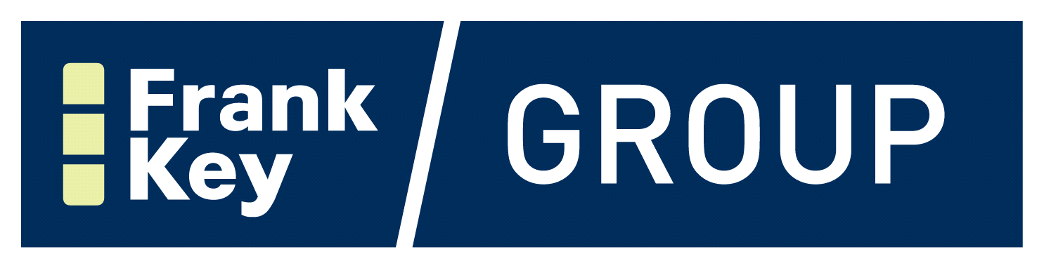

New opportunity to join Frank Key

Showroom Sales Representative

We have an exciting opportunity to join the Frank Key team:

Job title: Showroom Sales Representative
Location: Sheffield
Contract type: Full-time
Hours of work: 44.5 (Monday-Friday and every other Saturday 08:00am-12:00pm)
Shift Pattern: 08:00am-17:30pm (1 Hour Unpaid Break)
Role duration: Permanent

The main responsibilities of the role will include:

- Meeting sales goals and objectives as agreed with Branch Manager.
- Maintaining the showroom and its displays in a professional and tidy manner.
- Providing a first class and timely service to customers at all times.
- Supervising showroom staff activities and progress, including conducting performance reviews.
- Maintaining compliance with Frank Key policies and contractual obligations

Job Requirements

Excellent customer service and attention to detail | Essential
Full clean UK driving licence | Essential
Experience working in a kitchen and bathroom showroom | Essential
Experience in performing on site measures and plans | Essential
Experience of working with Fusion and KBB software | Desirable

Do you embrace our values?

- Friendly – A positive attitude and a smile go a long way.
- Supportive – We take care of our customers, and we take care of each other.
- Excellence – Ordinary just isn’t enough for us. We aim to surpass expectations at every opportunity.
- Integrity – Our approach is honest and sincere, and we apply it consistently and accurately.

Our Benefits Package

We offer a competitive and comprehensive benefits package.
- Competitive salary plus bonus.
- Monthly Pay.
- Annual Pay Reviews.
- Enhanced Holiday Entitlement to reward Company service.
- Company Pension Scheme.
- Training and Development Opportunities.

We’d love to hear from you. Please send your CV and Cover Letter to our People Team:
- By email: Careers@frank-key.co.uk or
- By post: Frank Key Group, Head Office, Sansom House, Portland Street, Daybrook, Nottingham, NG5 6BL

If for any reason you require the application form in another format, or need help in filling out the form, please contact our People Team at Careers@frank-key.co.uk or by telephone on 01159 208 208.

We’re a great place to work! We therefore receive a high volume of applications. We aim to respond to all applicants but unfortunately it isn’t always possible. If you don’t hear from us within two weeks, we won’t be continuing with your application at this time.

Please note that any CVs or application forms submitted to us will be kept for a period of six months.

